The Golden Age in Asgard

In the morning of time when everything was new and fresh and good, the Æsir, or the gods, enjoyed their lives in sweet content. Each untroubled day was filled with happiness, the sun rising and setting undisturbed by clouds, with the weather neither too hot nor too cold. At night the sky sparkled with stars until the moon rose and filled the landscape with milky light and soft shadows. In those days the Æsir were able to sleep untroubled with worries of any kind, past or future, for they were oblivious of Time.

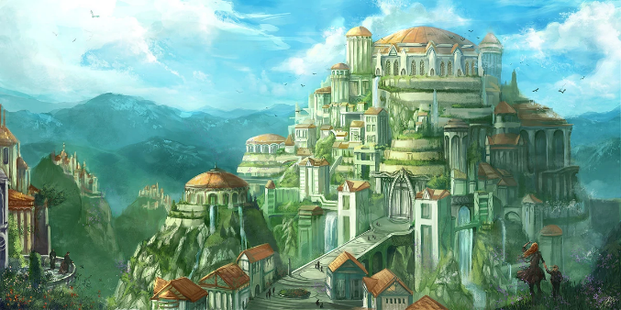
Time was there, but the Æsir were not part of it: Odin was their father and Frigg their mother and the rest of the gods and goddesses made up a happy, young family. When they got up and looked in their golden mirrors they saw the same unchanged likeness as was there the day before, and as would always be in the future. For the gods had access to the secret of eternal youth. This secret reposed in a magic fruit: enchanted apples in the keeping of a flaxen-haired goddess called Idunn. Every day she gave each of the Æsir one of her sharp-sweet apples to eat and as a result they never grew old.

The flowery landscape of Asgard remained at that sweet scented season when spring is just about to turn into summer. The fields, cropped by woolly sheep and grazed by herds of gentle deep-red cows, resembled smooth green lawns. In between the forest trees the dappled deer flitted like flecks of sunlight. The birds sang from the branches and the wind in the leaves was a passing sigh of contentment. From the mountain tops the cataracts dropped and hung and dropped again like veils of white gossamer; and the blue lakes which reflected their fall were smooth as glass.

In his capacity as the father of all, Odin had to watch and care for his family. To help him with his work lie, on the topmost peak in Asgard, an eagle’s eyrie of a palace with a view over all the nine worlds in the Tree.

These nine worlds stretched from Asgard, the world of the Æsir in the topmost branches, to the dead world of Hel far down at the Tree’s lowest root. In the early days of Asgard, Odin used to sit brooding on the throne in his palace eyrie which he called Hlidskialf or High Nest. He was concerned about the affairs of the whole universe and when he sat there he was able to see what everyone was doing and to understand everything he saw. This was not only a tremendous privilege but also a tremendous responsibility and on that account no one but Odin was allowed to sit on this high seat. Odin’s constant companions in High Nest were two friendly wolves. Because the father of the gods needed no food himself, he gave the delicacies which stood on the table to the two wolves. It seems that they never refused for their names were Geri Greediguts and Freki Gobble-up. For Odin, wine was both meat and drink.

As he sat brooding over the nine worlds, two ravens named Huginn (Thought) and Nluninn (Memory) perched on his shoulders, whispering into his ears every scrap of news which they saw or heard tell of. At crack of dawn every day he pushed them off to flap all around the universe and they returned in time for breakfast. Much of Odin’s information came from them and they are the reason why he is sometimes called the raven god.

Quite often Odin used to go in disguise to visit the other worlds below. On these occasions he appeared as an old, old man apparently blind in one eye, but with his other eye burning so fiercely that it would root an observer to the ground. Odin was forced to make these journeys because he knew the future: they were his way of preparing for the coming Ragnarok. It was during these journeys of preparation that he adopted so many different names, each of which referred to a twist or turn in the development of his being. ‘One-eyed’, ‘Flame-eyed’, ‘Masked one’, ‘Hanged god’ were all different ways of describing Odin.

Before Time was forced upon the gods in Asgard they continued to live in happiness, peace and prosperity. Odin’s wife, and mother of the Æsir, was Frigg. From High Nest Odin could easily see his wife’s palace in the western part of Asgard. It was called Fensalir and was a spacious and airy building full of light. There sat Frigg, surrounded by her handmaidens as she worked with her strong, slim fingers, teasing golden threads between her distaff and her jeweled spinning- wheel to weave later into summer clouds. Her hair hung down in two thick braids as fair and fine as the magic flax she spun. Her face was beautiful but her deep blue eyes were sad: she knew there were sorrows to come.
The eldest son of Frigg and Odin was the boisterous god Thor. A red-haired, red-bearded rascal of a god, he always acted first and thought last, a tendency which frequently landed him in trouble.
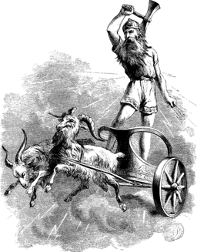
Thor was the god best loved by the people of Midgard. They enjoyed his rip-roaring passage across their skies in his chariot drawn by two mammoth-sized goats - Toothgnasher and Toothgrinder. At that time the peals of thunder boomed from the wheels of his war-wagon and lightning exploded as he hurled his blazing hammer.

In addition to his famous hammer, Miolnir the Mullicrusher, Thor also owned a strength increasing belt. This was perhaps his best treasure, for when he buckled it on, his already enormous strength was doubled. His third precious possession was a pair of iron gauntlets. Without these he could not have grasped his fiery hammer, or caught it when it flew back to him like a boomerang after each throw.

Men loved Thor because he gave them good crops. When his sheet lightning flashed across the fields of heavy-eared corn waiting to turn color, they said he was ripening the yield; when his fork lightning dazzled the eastern horizon they knew he was hunting trolls and doing battle with the giants. So men called him ‘Whip-it-up Thor’, and ‘Defender of Asgard and Midgard’, ‘Adversary’, ‘Slayer of giants and trolls’ and especially ‘Foe of the Midgard Serpent’.

Thor’s estate in Asgard was Thruthvangar, the Paddocks of Power, where stood his castle hall Bilskirnir or Lightning. That building had five hundred and forty rooms - the most extensive mansion known to man. Here he lived with his beautiful wife Sif, whose long hair was made of pure gold. She was the goddess of the cornfields and her long, shining hair - which has a story of its own - rippled over her shoulders like the ripening wheat. Of course it goes without saying that the dining table in Thor’s hall Bilskirnir groaned with meat and drink for above all Thor was a startling eater who had been known to finish a whole ox and drink three barrels of mead at one sitting. Even his enemies the giants could not do better than that.

Odin’s and Frigg’s second son was Balder, a person of very good report indeed. He stood out even among the Æsir. He was the fairest of the gods, so fair-haired and pale-skinned that a power of light beamed from him. Everyone loved Balder and he himself loved all things, small and large, beautiful and ugly. He lived in Breidablik, the Broad Gleaming Palace with his wife Nanna. In those days no-one in Asgard was unhappy.
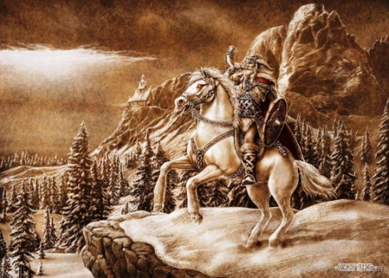
Living in Asgard and counted as one of the Æsir was Heimdall. Men on earth called him the white god and considered him a mighty and holy god but it is not clear where he came from. He was not a son of Odin and it is said that nine women, all sisters, mysteriously gave birth to him. He is sometimes called Gullintanni or Golden Teeth, for his teeth were made of living gold; his horse was called Gold-Topping from its mane of fine gold wires. Heimdall had his stronghold, a palace that was more of a barbican than a house, at the very edge of Asgard, close to Bifrost Bridge. There he stood sentinel, watching out for the giants’ assault on the bridge. He could sleep like a bird with one eye open and it is said that his ears could detect the noises made by blades of grass as they grew or the hairs getting longer on a sheep’s back.

Slung from a baldric over his shoulder Heimdall carried at the ready a mighty bugle, Giallarhorn, the alarm horn, whose blasts reached every nook and cranny of all the nine worlds, from highest to lowest. When the giants cross Bifrost Bridge and the Ragnarok begins, Heimdall will blow on Giallarhorn to call the gods and everyone who is on their side to fight against the powers of evil.
Another god, Vidarr, was also preparing for the Ragnarok. Vidarr, a strange, silent god, said to be the next strongest to Thor himself, had charge of a mysterious thing called the Thickmost Shoe. Just as in Hel the nail trimmings of dead men were used to build the dragon longship Naglfar, so in Asgard the ends and snippets of leather thrown away by cobblers on earth were fashioned into a great, thick shoe. When the time for the last battle arrives, Vidarr will pull that magic shoe onto one of his feet to stamp on one of the worst enemies of the gods. If the pieces of leather collected for so long in Midgard prove to have made a shoe big enough and strong enough, all will be well. Otherwise… who knows?

Odin’s brothers Hoenir and Lothur also still lived in Asgard as did the mysterious god Mimir whose severed head was later the source of all the knowledge of all time, past, present and future. In the early days, however, he lived as the other gods, in peace and prosperity.

Some of the old books describe the World Ash Tree as Mimir’s Tree or Mimir’s Wood, showing how important and powerful a god Mimir must once have been. He is also sometimes called Treasure-Mimir a name which recalls the days when he was not only wise but a famous smith who created treasures for the gods.

During this Golden Age, the Æsir enjoyed happy married lives. Frigg, Sif, Idunn and Nanna have already been mentioned. Later, other goddesses came to live with their husbands in Asgard. Gerda and Skadi were two giant maidens, who were taken in to the world of the gods. It is said that when Gerda, a woman of surpassing beauty, lifted the door latch of her home, a light was reflected over all the northern sky. As for Skadi, she was forever out on snowshoes or skis, hunting animals with her bow and arrows. She is often referred to as the snowshoe goddess, or the goddess on skis. Before she married into Asgard, her home was in the icy mountains and frozen fords where the cracking, creaking glaciers clave exploding icebergs, a northern region which is well named Thrumheim, the Home of Clamor.
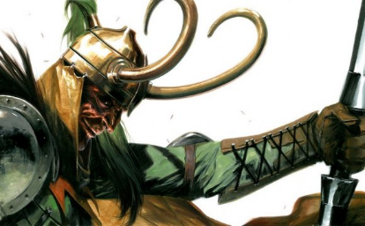
There is also counted among the heavenly powers one whom some call the Mischief Maker of the gods, the first father of lies. He is a living shame to everyone whether mortal or divine. His true name is Loki - some call him Loptr - son of the giant Farbauti. Loki is handsome but inside he is the soul of spite and fickleness. He is eternally getting the gods into trouble and quite often he pulls them out again with his crafty advice; back and forth he toys with them, from now until the end.

