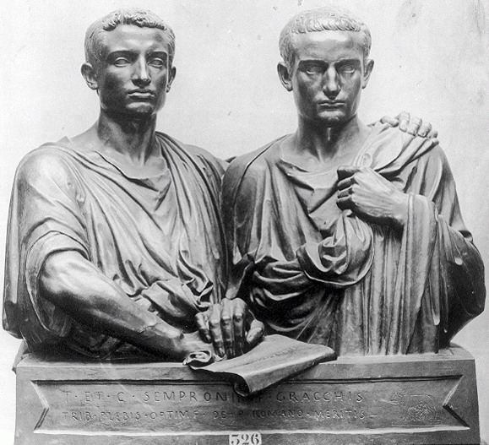
The Gracchi Brothers

In 135 BC, a massive slave revolt occurred in Sicily. This was the first major slave revolt in the history of Rome. The slaves across the island rose up and butchered their former masters. The revolt, however, did not end well for the slaves. Once the slaves were in charge of the island, chaos ensued. They had no effective leadership with which to organize themselves. In 132 BC, the Roman army put down the revolt. Over 20,000 of the starving slaves were nailed to crosses and publicly crucified.

Like much of Italy to the north, the island of Sicily had consisted predominately of large patrician-owned agricultural estates, which they had acquired through questionable means. These estates were worked by slaves, who had become far less expensive due to all of Rome's recent conquests. Patricians dominated land-ownership and production, leaving the plebian masses with virtually no land-owning opportunities. Many moved to the cities, especially Rome, where they became just another one of the thousands of plebeians crowding the streets. Most became day-laborers, barely able to support themselves. They survived because of the inexpensive grain, sometimes even doled out to them for free, that Rome contracted from Egypt or the wealthy patrician estates. While this grain welfare program was an impressive display of power and compassion by Rome, one could also view it as a means by which the wealthy patricians kept the plebeians just happy enough to not rebel or disrupt the social order, in which being a patrician had never been better.

It was in this time of unrest that Tiberius Gracchus first began to seek the political support of the landless poor by fighting for their rights. In 133 BC, Tiberius Gracchus was elected to the office of Tribune. The position of Tribune was a relatively new position created as part of the centuries long “Struggle of the Orders”. These plebeian-elected officials represented the plebeians and held veto power over almost all government decisions.

Tiberius Gracchus proposed strong enforcement of an old law limiting the amount of land that any man could own to 500 acres per family member. This would mean the wealthy patricians would be forced to turn thousands of acres over to the government. From these acres, the landless plebeians would be given small estates. Tiberius argued to the wealthy patricians that his plan would reduce the danger of revolt by a plebeian mob, a real fear after the recent slave revolt in Sicily. He also pointed out that turning landless plebeians into land-owners would boost the number of soldiers in the Roman army, since at that time, soldiers were required to be citizen land-owners. Though his arguments were valid and his intentions good, the way Tiberius went about achieving his reform was not.

By this time, the Struggle of the Orders had achieved the significant breakthrough dictating that the Popular Assembly could pass some legislation. The Senate was still very prestigious and influential, but technically was not required to pass all legislation. Still, to this point nobody had dared disrespect the Senate. That was about to change.

Naturally, the Senators would be against any reforms which might cost them some of their own land. The Senate voted on Tiberius’ measure and resoundingly defeated it. Tradition would dictate that this meant the proposal would die. However, Tiberius rallied the Popular Assembly, and in a stunning development, convinced them to vote for the measure, passing it into law without Senate approval. However, the Senate still controlled one major factor: the budget. The Senate continually voted to deny the necessary funding to implement the law.

The Roman government came to a virtual standstill. Tiberius was afraid his reforms might never be fully implemented without his support as Tribune. However, he faced a problem; consecutive terms as tribune violated the Constitution. Tiberius decided to run for Tribune again in 132 BC, citing the importance of what he was trying to accomplish. The Senators felt Tiberius was a threat to their power, their land, Roman tradition, and the Roman Republic. As Tiberius was holding an election rally, the Senators grabbed clubs and attacked him and his followers, savagely beating them to death in public. The plebeian masses were shocked.

The attempted reforms of Tiberius were now championed by his brother, Gaius Gracchus. In 123 BC, he was elected Tribune, just like his brother. Gaius not only pushed through the land reforms, but also public works projects. However, Gaius became too progressive for many Romans when he attempted to offer Roman citizenship to all Italians. In 121 BC, Gaius failed to win reelection to his third term, and it was widely believed that the Senate had interfered with the vote. Gaius and his supporters began to protest, and a brawl broke out at one of the demonstrations. The Senate and Consul ordered several thousand soldiers to attack the plebeian mob. Gaius and his supporters were all murdered.

The legacy of the Gracchi Brothers is difficult to determine. By pushing their land bill through at all costs, the Gracchi Brothers exposed the Achilles heel of Rome’s republican government: The Senate had no real power. Future demagogues now had an avenue to power that could avoid the checks and balances of the Senate. However, it could be argued that the Gracchi Brothers had worked largely within the system, and never violently. More appalling were the actions of the Senators, who set a terrible precedent by resorting to violence to suppress the Gracchi Brothers. The Senate’s unjustifiable breach of etiquette paved the way for the ultimate collapse of the Republic by introducing murder as a common tool for elected officials.

The reforms of the Gracchi brothers were short-lived. What is more important about them is that they changed Roman politics and unknowingly began the “Roman Revolution”. From the time of the Gracchi Brothers on, Roman politicians in the Republic were divided between the optimates (Latin for “Best Ones” – Our source of the word “optimum”) and the populares (Latin for “Men of the People” – Our source of the word “popular”). No longer was the Senate the overwhelmingly dominant power it once had been. This instability would gradually lead to Roman dictators and fall of the Roman Republic.

Name________________________________ Per: ________ Date: _____________
THE ROMAN REVOLUTION:
The Gracchi Brothers vs. The Senate
- Explain Tiberius Gracchus’ land reform goal:

- Make a list of each time either Gracchi Brother or the Senate does something of questionable legality or morality in order to achieve their political objective. You should have AT LEAST 4 IN TOTAL.
Gracchi Brothers Questionable Action/Decision | Senate’s Questionable Action/Decision

- Explain the Gracchi Brothers’ legacy.

- Explain the damage the Senate did to the Roman Republic through their actions.

