Directions:
The Imperial Tomb
by royal historian Sima Qian

As soon as the First Emperor became king of Qín, excavations and building had been started at Mount Lì, while after he won the empire more than seven hundred thousand conscripts from all parts of the country worked there. They dug through three subterranean streams and poured molten copper for the outer coffin, and the tomb was filled with models of palaces, pavilions and offices, as well as fine vessels, precious stones and rarities.
Artisans were ordered to fix up crossbows so that any thief breaking in would be shot.
All the country’s streams, the Yellow River, and the Yangtze were reproduced in quicksilver and by some mechanical means made to flow into a miniature ocean. The heavenly constellations were shown above and the regions of the earth below in fine pearls.
The Second Emperor decreed, “It is not right to send away those of my father’s ladies who had no sons.” Accordingly all these were ordered to follow the First Emperor to the grave. After the interment someone pointed out that the artisans who had made the mechanical contrivances might disclose all the treasure that was in the tomb.
Therefore after the burial and sealing up of the treasures, the middle gate was shut and the outer gate closed to imprison all the artisans and laborers, so that not one came out. Trees and grass were planted over the mausoleum to make it seem like a hill.
Below is a description by Sima Qian, a great Chinese historian (145 BCE – 87 BCE). Use the pictures to the right to help you visualize what is in the tomb. Look up underlined words. Once you have a clear picture in your mind, fill in both sides of your assignment.
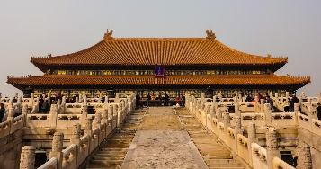
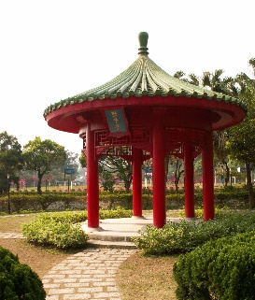
pavilion
palace
Read the document detailing Shi Huang Di’s tomb. Fill in the details, then based on the information you have, sketch the inside of the tomb.

Details:

How many conscripts worked on the tomb? _________________________________________

What are conscripts? ______________________________________________________________

What kinds of models were placed in the tomb?

- _____________________________________________________________

- _____________________________________________________________

- _____________________________________________________________

What else filled the tomb besides models? ______________________________________________
____________________________________________________________________________________

How was the tomb protected? ________________________________________________________

What rivers were made out of mercury? ________________________________________________

What filled the model sky? ___________________________________________________________

What happened to the artisans and workers who knew about the traps? ____________________
____________________________________________________________________________________

How was the tomb disguised? ________________________________________________________
____________________________________________________________________________________

GLUE
Sketch the inside of Shi Huang Di’s tomb. Start with the copper coffin in the middle, then add the two rivers, then add the buildings, gates, etc.

