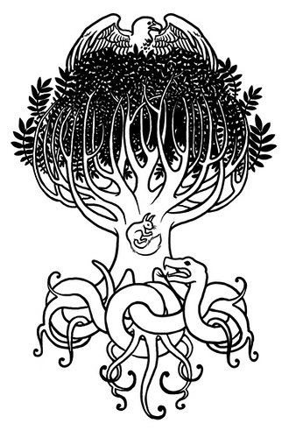
Yggdrasill, the World Ash
Name:
You may not be able to see it from the earth, but it is there. Think of a force like that which exists between a magnet and a piece of iron. You know it is there although you can’t see it or touch it. To mortals Yggdrasill may be invisible, but without the support of the great Ash Tree everything would disintegrate and explode into infinity.
Yggdrasill is, of all trees, the largest and stateliest. Its branches overhang all the nine worlds and spread out above the sky. There are three roots to the Tree, stretching far and wide to support its trunk and branches: one root reaches into Asgard where the gods live; the second winds out to Jotunheim where the giants live; and the third root twists down to Niflheim, the world of mist and ice.
At the tip of each root bubbles a well. The most important of these is the well of Mimir. Once a god, only the head of Mimir now remains, kept alive by magic herbs. His head is full of wisdom because he drinks water from the well every day. The head can still speak when it is addressed by the father of the gods, Odin. This is fortunate, for Mimir and his well hold the wisdom, the hindsight and the foresight of all eternity and at the end of time Odin must consult with Mimir if he hopes to save himself, the Æsir and his world.
Odin in all his glory ruled Asgard, the Gods’ Enclosure, which he and his sons built above the clouds, supported by Yggdrasill over the center of Midgard. The palaces of Asgard were buildings of pure delight. First the gods erected Gladsheim or Joyous Home, said to be the finest building ever constructed. Here are to be found their twelve thrones, one higher than the rest for Odin himself. Inside and outside everything was made of burning gold. They built a second mansion as a shrine for the goddesses. It too was very beautiful: men call it Vingolf or Friendly Floor. Their next job was to plan a workshop, for labor with the hands was considered to be an honorable and worthwhile occupation. In the workshop they set a forge and made in addition the first hammer, tongs and anvil, and by means of these all other kinds of tools. They made metal, stone and wood, particularly that metal called gold, enough to have all their utensils and dishes of gold. That’s why this time was called the Golden Age.
There was also a corner of Asgard called the Hill of Heaven: it stood at the far end of Asgard by the foundation stone of the rainbow bridge called Bifrost. Bifrost was the bridge built by the gods between Midgard and Asgard, the road from earth to heaven. It was and is exceedingly strong in spite of its frail appearance for it was made with more artifice and cunning than any other of the gods’ handiwork. All the gods except Thor ride daily over Bifrost Bridge to the well of Wyrd, where they meet in judgment. Thor goes there on foot, wading the rivers he crosses on his way, for the thunder and lightning that accompany his chariot on normal journeys would shake the delicate balance of the bridge. And that will not happen until the end.
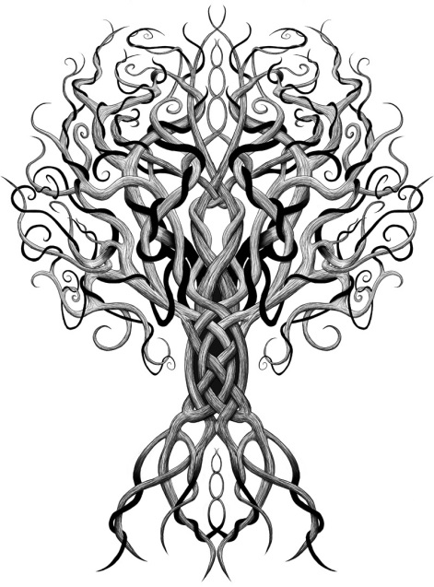
Jotunheim, the world of the giants, is always a worrying place both for gods and men. When you are surrounded with enemies you cannot help but feel apprehensive, and when those enemies are mountain giants, frost giants and fire giants who are quite likely to gobble up anyone who trespasses in their domains, then apprehension turns to terror. Fortunately, the gods are well prepared both to resist attack by giants on their own stronghold of Asgard and to carry the assault to Jotunheim. It is Thor, of course, who continually keeps them at bay with his famous hammer.
Further down the tree a plummeting, plunging, zigzagging road leads to Niflhel. This road has black vertical cliffs; each further descent enveloped in gloom, each twist of the track howling with ice-cold winds screaming upwards from Niflheim, the realm of mist and snow. The entrance to Niflhel is a grim black hole set among precipitous cliffs and ravines. Snowflakes blow out of it in blizzards. This dark cavern is guarded by a fearsome hound with a bloody chest whose very name is like a growl, Garmr. He is chained to his post, for if he were free he would leap above, ravening wildly around the upper world attacking both men and gods. The blood on the shaggy hair of his chest comes from those who pass him but are so terrified with what they see of Niflhel that they try to escape back into the world of sunlight.
All roads to the Underworld lead down, whether from Asgard, Midgard, or Jotunheim, and not only dead men are to be found there but also the phantoms of gods and giants. Sinners from Midgard go to Niflhel, especially oath-breakers, murderers and those who have been disloyal. Those who deserve punishment receive it everlastingly. There is an island in Niflhel called Naastrand, the Corpse Strand, on which stands a great torture chamber, a horrid place of punishment. This hall is always out of reach of sunlight and its doors face the dark north. At first the walls and roof appear to be made of wickerwork, but the plaited bars are not wooden wattles but the entwined bodies of poisonous serpents whose gaping jaws dribble venom from their fangs to burn the sinners crowded underneath. Here are imprisoned the oath-breakers, murderers and adulterers. Some, no doubt, have died a second death on the way to this place; for they have had to wade the terrifying river Slid, full not of water but of knives, daggers and sharp swords.
At the wharf by the shore of Naastrand, a dreadful longship is being built. This is Nailfarer Naglfar, the dead men’s nail ship, built through all time from the toe and finger nails of those who go to their death without having their nails trimmed. The captain of that vessel (who shall be nameless for the present) will be the greatest sinner of all, unfaithful, disloyal and even indirectly the murderer of a god. He and his grisly crew will fight on the side of the frost giants at the Ragnarok - so all good men who wish to delay that day of doom should see to it that their nails are always neat and short.
The queen of this far flung kingdom is called Hel. Her complexion is half livid, half normal; and she is hideous to look at. Hel herself is not dead, but a prisoner who was banished there by the gods.
The other worlds of the tree are Muspellheim, home of the Fire Giants; Alfheim, home of the Light Elves; Vanaheim, home of the Vanir (another race of gods); and Svartalfheim, home of the Dark Elves (dwarves).

Yggdrasill and the Cosmology of the Vikings Assignment
While reading Yggdrasill, the World Ash, highlight or underline parts of the story that describe the physical appearance of the Viking cosmology. After reading you will create a drawing depicting the tree and the nine worlds of the Viking cosmology. Use the descriptions from the text to help shape your drawing. This is to be what you imagine the tree and worlds to look like. There is no necessarily right or wrong way to draw the assignment as long as you use the text to guide you. Be sure to draw and label all nine worlds in your drawing; include details mentioned in the text.
1. Muspelheim: World of the Fire Giants
2. Alfheim: World of the Light Elves
3. Vanaheim: World of the Vanir
4. Asgard: World of the Æsir
5. Midgard: World of the Humans
6. Jotunheim: World of the Giants
7. Svartalfheim: World of the Dark Elves or Dwarves
8. Helheim (Niflhel): World of Hel (the realm of the dead)
9. Niflheim: World of arctic mist and ice

Rough Draft

